OUM
MD.050 Functional design document
Service Management – After-Sales
Added Features Set #3

Author: Nader Sayed
Creation Date: Dec 20, 2022
Last Updated: Dec 20, 2022
Document Ref: MD.050
Version: 1.0

Approvals:
<Approver 1>
<Approver 2>

Document Control

Change Record
3
Date | Author | Version | Change Reference
20-Dec-22 | Nader Sayed | 1.0 | No Previous Document

Reviewers

Name | Position

Contents
1 Document Control ii
1.1 Change Record ii
1.2 Reviewers ii
2 Introduction 1
2.1 Purpose 1
3 TERMINOLOGY 2
4 Appointment System 3
5 Open and Closed Issues 4
5.1 Open Issues 4
5.2 Closed Issues 4

Introduction

Purpose
The purpose of this document is to describe the business flow and requirements for the following new added features set #3, this set will include the following updates on the after-sale’s solution as part of the total CEC after-sales solution:
- Dashboards

TERMINOLOGY

The following table depicts the terminology (with its corresponding explanation) used in the course of this document:

Term | Description
JC | Job Card
AR | Receivables
SA | Service Advisor
AFS | After-Sales Management Solution
INV | Inventory

Dashboards
This feature is to add dashboards to almost of the screens in the application, the following are the needed dashboards:

- Homepage:

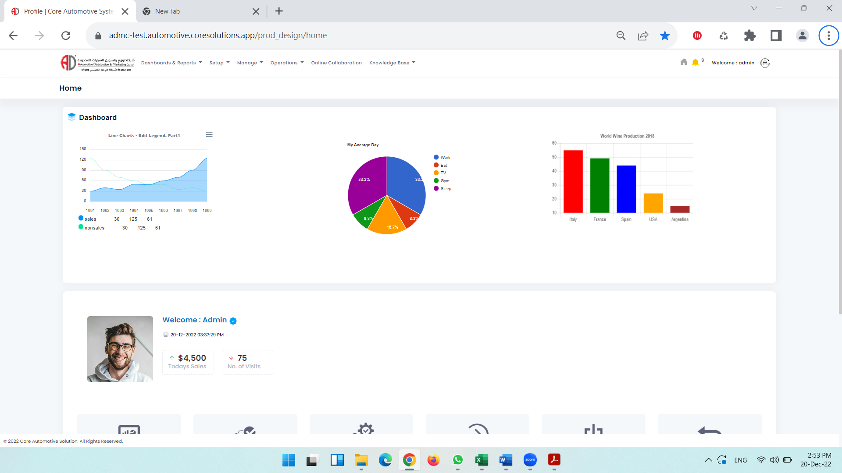

  - Jobs Dashboard:
    - Open Jobs: show total number of opened JC in the service centers assigned to the login user.
    - Waiting Parts Jobs: show total number of waiting parts JC in the service centers assigned to the login user.
    - Pending Jobs: show total number of Pending JC in the service centers assigned to the login user.
    - Ready for Invoicing Jobs: show total number of ready for invoicing JC in the service centers assigned to the login user.
    - Parts Added Jobs: show total number of Parts added JC in the service centers assigned to the login user.
    - Parts Arrived Jobs: show total number of Parts Arrived in the service centers assigned to the login user.
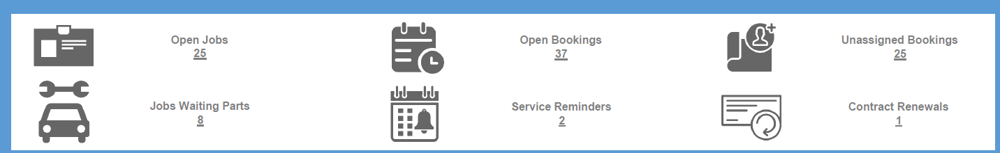

  - Service Center Overview:
- Show the Job card actual amounts per service activity (Cash, Warranty, …..)

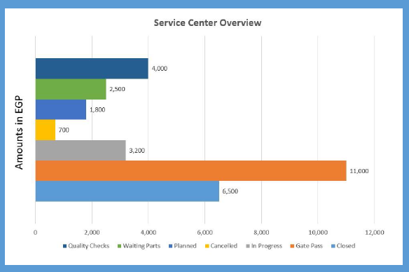

- Manage Jobs:

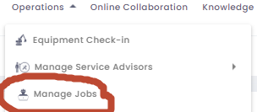

2.1- Job Card Status: show job cards number per each job card status in the assigned service center to the login user

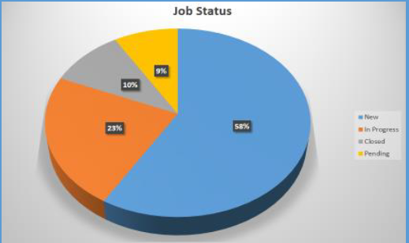

Open and Closed Issues

Open Issues

ID | Issue | Resolution | Responsibility | Target Date | Impact Date

Closed Issues

ID | Issue | Resolution | Responsibility | Target Date | Impact Date

